Question: Why is the temperature seasonality measured as a standard deviation and the precipitation as a CV? Interpret the results and produce nice tables and figures.
Temperature seasonality and precipitation variability are often measured using different statistical measures due to the nature of the data and the way these factors vary over time.

### Temperature Seasonality (Measured as Standard Deviation - Sd)
- **Temperature Variation:** Standard deviation (Sd) is a measure of how much individual data points deviate from the mean. In the context of temperature seasonality, using the standard deviation allows us to understand how much the temperature fluctuates around the average temperature over a specific period (e.g., monthly or annually). A higher standard deviation indicates greater variability in temperature, capturing the extent of seasonal fluctuations.

### Precipitation Seasonality (Measured as Coefficient of Variation - CV)
- **Precipitation Variation:** Coefficient of Variation (CV) is a relative measure that expresses the variability of a dataset relative to its mean. It's calculated as the ratio of the standard deviation to the mean. Precipitation data often has a wide range of values, and the CV standardizes this variability by considering the ratio of the standard deviation to the mean. It's useful because it provides a measure of variability in relation to the average amount of precipitation. Higher CV values indicate more variability in precipitation relative to the mean.

### Why Different Measures?
Temperature and precipitation exhibit different patterns and characteristics in their variability. Temperature tends to fluctuate around a mean value, and the standard deviation helps capture the extent of these fluctuations. On the other hand, precipitation can vary significantly in terms of both the amount and frequency, hence the use of CV to normalize this variability relative to the mean.

Both measures offer insights into the variability of these environmental factors, aiding in understanding their seasonal patterns and potential impacts on various ecological processes, including effects on bee species and their habitats.
Title: Distribution patterns of bee Eulaema nigrita

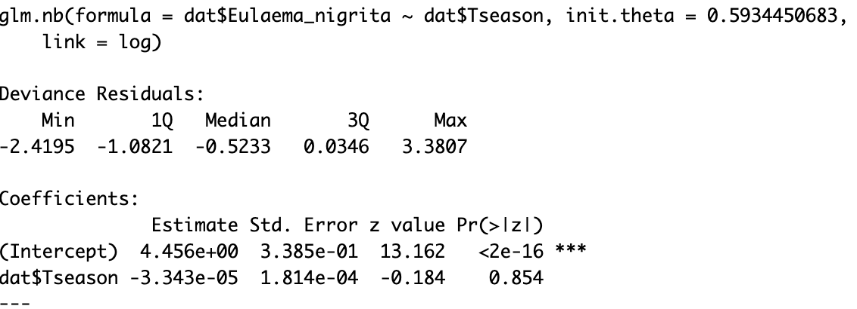
Temperature seasons slightly negative affects the bee distribution.

Draw a log(y) vs x plot. Draw a y vs x plot.
No natural for temperature std
No negative, that is why for cv precipitation
Absolute scale (y) for exponential graph.
Eta vs x ( two group means, on the slope beta)
If beta = 0.1, increase x = 1 increase the slope 0.1 (10%), the same if we do y vs x/mean x, or y vs log(x)

The mean annual temperature (MAT) refers to the average temperature of a location over the course of a year. It represents the average of all the individual monthly temperatures recorded throughout the year.

The Mean Annual Temperature (MAT) plays a significant role in shaping the distribution of bee species and their populations within ecosystems. Here's how MAT can affect bee distribution:

1. **Species Specificity:** Different bee species have specific temperature requirements for their survival, development, and reproduction. Some species thrive in warmer climates with higher MAT, while others are adapted to cooler temperatures. MAT helps define the suitable habitat range for different bee species.

2. **Phenology and Life Cycle:** MAT influences the timing of seasonal events like flowering and availability of floral resources. Bees, being pollinators, depend on flowers for nectar and pollen. MAT affects the timing of flowering, which in turn impacts bee foraging activities, reproductive cycles, and the synchronization between bees and their floral resources.

3. **Habitat Suitability:** MAT influences the geographical distribution of habitats. Bees tend to occupy habitats that align with their preferred temperature ranges. Higher MAT may expand the suitable habitat for certain bee species, allowing them to colonize new areas, while lower MAT might restrict their range.

4. **Nesting and Overwintering:** MAT affects the availability of suitable nesting sites and influences overwintering survival for bee populations. Some bee species require specific temperature ranges for nesting conditions, while others have adaptations for surviving colder temperatures during winter.

5. **Interactions with Other Factors:** MAT interacts with other environmental factors such as precipitation, humidity, and altitude. These interactions can have synergistic or compounding effects on bee distributions. For instance, higher MAT combined with adequate precipitation might create optimal conditions for certain bee species.

6. **Climate Change Impact:** Changes in MAT due to climate change can alter the distribution patterns of bee species. Shifts in MAT might result in changes to flowering periods, affecting floral availability and consequently impacting bee populations.

Understanding how MAT influences bee distribution is crucial for predicting how changes in climate might impact bee communities and their crucial role in pollination and ecosystem functioning. Researchers use climate data, including MAT, to model and forecast changes in bee distributions under different climate change scenarios, aiding conservation efforts and ecosystem management.

Altitude significantly influences bee distribution due to its impact on various environmental factors that affect the availability of resources, climate conditions, and habitat characteristics. Here's how altitude affects bee distribution:

1. **Temperature Variation:** As altitude increases, there's a general decrease in temperature, known as the lapse rate. Bees are sensitive to temperature changes, and different species have specific thermal preferences. Lower temperatures at higher altitudes might limit the distribution of certain bee species adapted to warmer climates. Conversely, some bee species are adapted to colder, mountainous regions and thrive at higher altitudes.

2. **Floral Composition and Phenology:** Altitude affects the types of plants and flowers available. Different altitudes have distinct vegetation zones with specific flowering periods and floral resources. Bees rely on flowers for nectar and pollen, and changes in floral availability due to altitude influence the foraging behavior and seasonal dynamics of bee populations.

3. **Precipitation and Humidity:** Altitude influences precipitation patterns and humidity levels. Higher altitudes often experience different rainfall patterns, including orographic precipitation in mountainous regions. This variation affects the availability of water sources and impacts both floral abundance and bee activities.

4. **Habitat Structure:** Altitude impacts habitat structure, including nesting sites and landscape characteristics. Changes in altitude alter the types of habitats available for nesting and foraging, influencing the diversity and distribution of bee species.

5. **Competition and Community Composition:** Altitude can create barriers that limit the movement of certain bee species, leading to distinct bee communities at different altitudes. Competitive interactions and species interactions change as bee communities adapt to the unique conditions of their altitude-specific habitats.

6. **Adaptations and Specializations:** Some bee species have specific adaptations to survive and thrive at different altitudes. These adaptations might include physiological changes to tolerate colder temperatures, alterations in nesting behaviors, or preferences for specific floral resources found at different altitudes.

Understanding the relationship between altitude and bee distribution is crucial for conservation efforts and predicting how changes in altitude due to factors like climate change or land-use modifications might impact bee communities. Researchers and conservationists often use altitudinal gradients to study how bee populations respond to changes in environmental conditions and to assess the vulnerability of species to environmental alterations along altitude gradients.

